Hacker rank Numpy
1. The NumPy (Numeric Python) package helps us manipulate large arrays and matrices of numeric data.
To use the NumPy module, we need to import it using:
import numpy
Arrays
A NumPy array is a grid of values. They are similar to lists, except that every element of an array must be the same type.
import numpy

a = numpy.array([1,2,3,4,5])
print a[1] #2

b = numpy.array([1,2,3,4,5],float)
print b[1] #2.0
In the above example, numpy.array() is used to convert a list into a NumPy array. The second argument (float) can be used to set the type of array elements.

Task
You are given a space separated list of numbers.
Your task is to print a reversed NumPy array with the element type float.
Input Format
A single line of input containing space separated numbers.
Output Format
Print the reverse NumPy array with type float.
Sample Input
1 2 3 4 -8 -10
Sample Output
[-10. -8. 4. 3. 2. 1.]
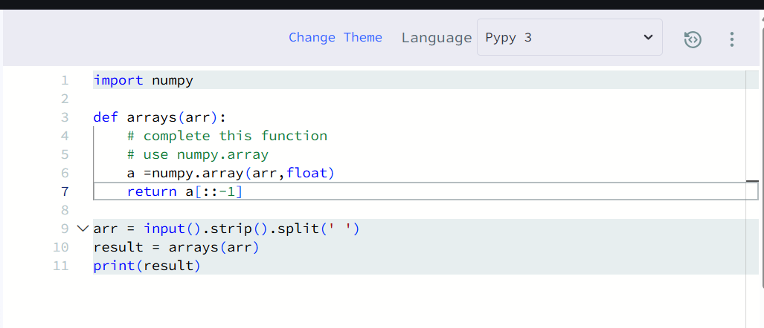
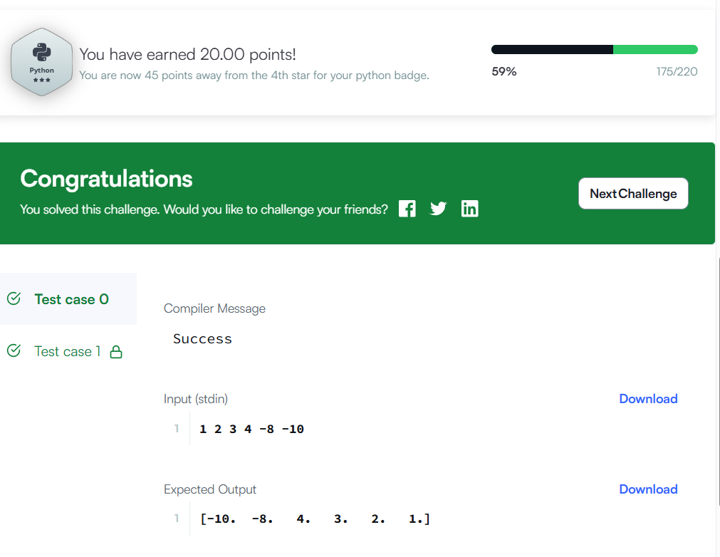
2. shape
The shape tool gives a tuple of array dimensions and can be used to change the dimensions of an array.
(a). Using shape to get array dimensions
import numpy

my__1D_array = numpy.array([1, 2, 3, 4, 5])
print my_1D_array.shape #(5,) -> 1 row and 5 columns

my__2D_array = numpy.array([[1, 2],[3, 4],[6,5]])
print my_2D_array.shape #(3, 2) -> 3 rows and 2 columns
(b). Using shape to change array dimensions
import numpy

change_array = numpy.array([1,2,3,4,5,6])
change_array.shape = (3, 2)
print change_array

#Output
[[1 2]
[3 4]
[5 6]]
reshape
The reshape tool gives a new shape to an array without changing its data. It creates a new array and does not modify the original array itself.
import numpy

my_array = numpy.array([1,2,3,4,5,6])
print numpy.reshape(my_array,(3,2))

#Output
[[1 2]
[3 4]
[5 6]]

Task
You are given a space separated list of nine integers. Your task is to convert this list into a 3X3 NumPy array.
Input Format
A single line of input containing space separated integers.
Output Format
Print the 3X 3NumPy array.
Sample Input
1 2 3 4 5 6 7 8 9
Sample Output
[[1 2 3]
[4 5 6]
[7 8 9]]
